ASSIGNMENT – 1
SUPERMARKET SALES DATA ANALYSIS
(TEAM LEADER)

1. BAR CHART
- Purpose: This bar chart shows the comparison of total sales across different branches. It helps identify which branch generates the highest revenue and which branch performs the least. This visualization is useful for analyzing branch-wise performance.

- Step-by-Step Process: Open Tableau Public/Desktop and load the supermarket_sales dataset.Click on New Worksheet.
- Change Marks type to Circle.
- Drag Product Line → to Detail.
- Drag Total → to Size.
- Drag Product Line → to Color.
- Drag Total → to Label.
- Adjust bubble size properly.
- Edit Title as: SALES BY PRODUCT LINE.

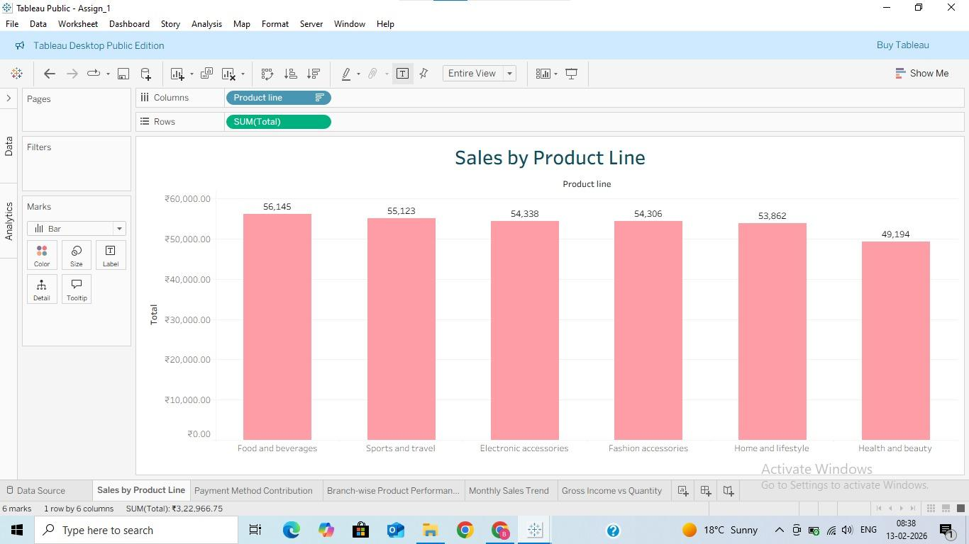

2. PIE CHART
- Purpose:This pie chart represents the distribution of sales based on payment methods. It helps understand which payment method (Cash, Credit Card, E-wallet) is most preferred by customers.

- Step-by-Step Process:
- Click on New Worksheet.
- Change Marks type to Pie.
- Drag Payment → to Color.
- Drag Total → to Angle.
- Drag Total → to Label.
- Click on Label → Show Percentage.
- Edit Title as: PAYMENT METHOD CONTRIBUTION.

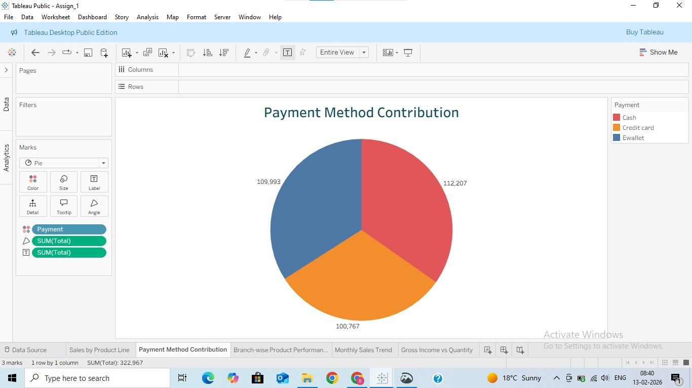

3. STACKED BAR CHART
- Purpose: This stacked bar chart shows how different product lines contribute to total sales in each branch. It helps analyze which product category performs better in each branch.

- Step-by-Step Process:
- Click on New Worksheet.
- Drag Branch → to Columns.
- Drag Total → to Rows.
- Drag Product Line → to Color.
- Ensure Stack Marks is ON (Analysis → Stack Marks → On).
- Edit Title as: BRANCH-WISE PRODUCT PERFORMANCE.

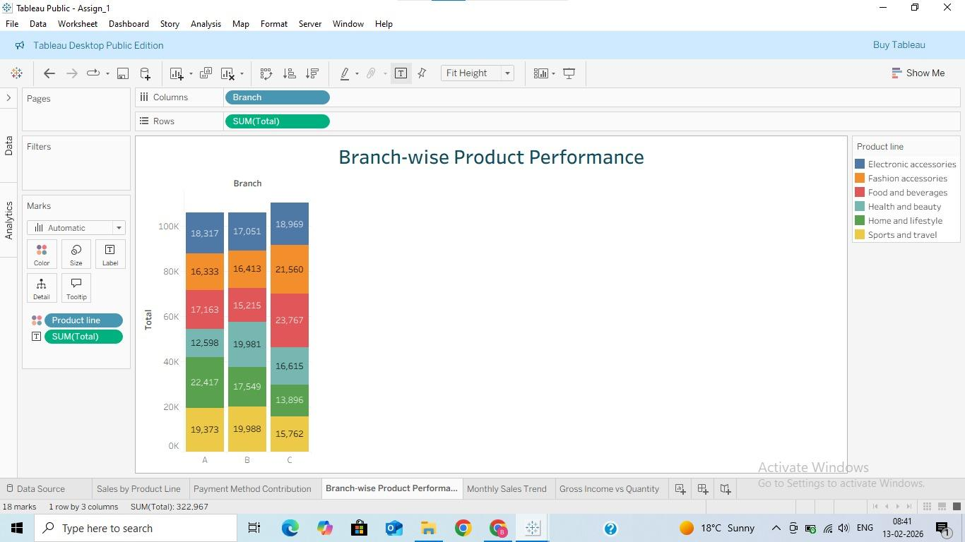

4. LINE CHART
- Purpose:This line chart shows the sales trend over time. It helps identify whether sales are increasing or decreasing from January to March 2019.

- Step-by-Step Process:
- Click on New Worksheet.
- Drag Date → to Columns.
- Convert it to Continuous Date (Month).
- Drag Total → to Rows.
- Select Line Chart from Show Me.
- Edit Title as: MONTHLY SALES TREND.

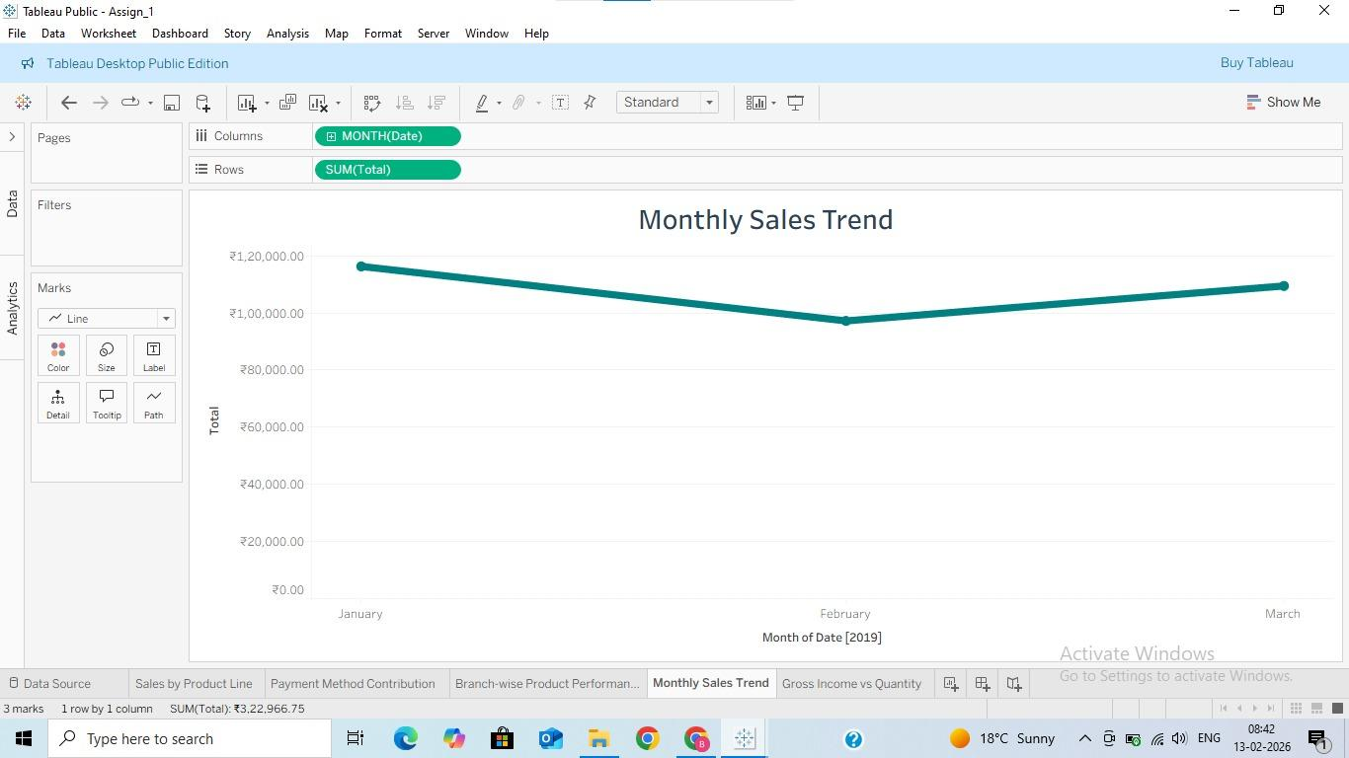

5. BUBBLE CHART
- Purpose:This bubble chart represents sales performance of different product lines. Larger bubbles indicate higher sales. It helps quickly compare category performance visually.

- Step-by-Step Process:
- Click on New Worksheet.
- Change Marks type to Circle.
- Drag Product Line → to Detail.
- Drag Total → to Size.
- Drag Product Line → to Color.
- Drag Total → to Label.
- Adjust bubble size properly.
- Edit Title as: GROSS INCOME VS QUANTITY.
